# Introduction

Current research in environmental justice demonstrates the need for using Geographic Information Systems (GIS) tools to investigate environmental equity distributions across demographics (Sheppard et al 1999, Glickman 1994, McMaster et at 1997, Sui and Giardino 1995). Several recent papers have catalogued the body of literature presented thus far to demonstrate what we know or don’t know about environmental equity (Bowen 2002, Maantay 2002, Harner et al 2002). The conclusions from these papers illustrate that many researchers are still trying to find appropriate and unbiased analytical methods, scale, and data to support or refute environmental justice claims. In this research, I examine the environmental equity in one Californian County, using information from the public drinking water system. I present a new analytical method and test it against a common method employed by other researchers. This research shows the promises for using both water quality information and continuous surfaces in GIS for environmental equity research.

The debate on environmental justice, while short, has been rather prolific. Many identify a 1982 protest in North Carolina as the seminal event. The mostly black residents of Warren County North Carolina challenged a proposal to store contaminated soils in local landfills. Although unsuccessful, the protest gained national recognition and the movement was born. In 1987, the United Church of Christ Commission for Racial Justice published its landmark report "Toxic Wastes and Race in the United States." This paper was the first major research showing a relationship between minority populations and poor environmental quality in the United States. In 1994, President Clinton signed executive order 12898, requiring that federal agencies abolish existing policies and prevent future actions leading to a disproportion of environmental hazards near communities of color or low income (Newton 1996). Since these events, two areas of environmental justice research have been performed (Sheppard 1999). The first, “distributive justice”’ focuses on equity in the distribution of environmental benefits and burdens. The second, “procedural justice” focuses on equity in procedures through which justice is achieved. Yet even with national attention, sweeping policy initiatives to reverse the trend, and definitive research goals, the extent to which discrimination-based or other policy-driven environmental inequities exist are still debated (Bowen 2002).

Many distributive justice studies have used census tract (or census county summaries) for demographic indicators, and United States Environmental Protection Agency (US EPA) Toxic Release Inventory Sites (TRI) as environmental condition indicators (Burke 1993, Perlin et al. 1995, Bowen et. Al 1995). Maantay (2002) provides an excellent review and analysis of the common pitfalls in recent research. These pitfalls include poor spatial resolution (often termed “scale”) in demographic data, a lack of comprehensive hazards databases, and unrealistic methods for determining exposure to poor environmental conditions. Bowen (2002) has concluded,

“The empirical foundations of environmental justice are so underdeveloped that little can be said with scientific authority regarding the existence of geographical patterns of disproportionate distributions and their health effects on minority, low-income, and other disadvantaged communities”

The outcome from both Maantay and Bowen lead us to question the conclusions from research on environmental equity due to problems of scale, data or analytical method.

Research on environmental equity that demonstrates how racial or ethnic minorities or those of lower economic status bear a disproportionate environmental burden has generally taken place on the county or census tract level. Cutter and Solecki (1996) argued that analysis at this scale does not adequately demonstrate environmental inequity, and demonstrate that disparate scales of data can skew results of environmental equity analyses. Census tracts, much less the county summaries used in some analyses, usually cover multiple communities with very different incomes and demographics.

Along with issues of scale, data used in environmental justice studies often suffer from heterogeneity and poor quality. For example, commonly used data for environmental condition are TRI or Accidental Chemical Release (ACR) sites. Records from both databases mix major chronic emission sites with one-time accidental releases, so mere counts of sites give little indication of chemical risks. The existence of a TRI or ACR site does not necessarily demonstrate ingestion of a chemical or pollutant by humans around that site. In fact, these records document release volumes rather than any real exposure information, and no real conclusions as to the amount of any one toxin ingested can be assessed. When there is significant exposure, it is typically associated with places of employment, rather than residences, of the most affected populations, whereas the census data are based on residence. In most cases, unless the environmental condition can be shown to cause health problems not seen in other areas, then the existence of a condition does not in and of itself denote an inequity (Foreman 1998).

Finally, despite and urgent need for models that adequately demonstrate if unequal burdens exist or not, the methodology employed to date in research on environmental justices continues to fall short (Bowen 2002). Most research applies geographic proximity analysis to reveal underlying patterns of equity. This common method sees if there is an existence of an inequity (TRI site) inside a demographic unit (census tract). Also called point-in-polygon overlay, some have argued that this method does not really define an inequity or undue burden (McMaster et al.1997). Using the proximity method, a TRI site might lie just inside a unit of high minority density, but on the border with high white densities. While statistical inference might indicate minorities bear the burden of poorer environmental quality, the conclusion is potentially a false positive. Since a point environmental condition dataset (and not a continuous environmental condition data set) is measured against a demographic group only positive existence can be established. This method, then, cannot measure the level of hazard against demographics.

Available data for public drinking water systems allow us to avoid many of the data quality problems that plague the studies based on toxic releases. This paper examines environmental inequities using the public drinking water system and demographics from the 2000 census. Input data in this analysis include high spatial resolution (“large scale” in cartographer’s terms) data on both demographic characteristics and environmental condition. This study uses a comprehensive hazards database that represents toxins actually ingested by the general public, and includes temporally continuous datasets where the level of exposure and consequent hazard with respect to demographics can be assessed. Given the resolution of the environmental condition data, there is no need to spatially aggregate the demographic data to unmanageably heterogeneous units (e.g., census tracts or counties) as in previous studies. Using quantitative tools, the analysis tests whether there indeed exists an unequal burden in distribution of drinking water quality by minorities and low-income groups. Indicators for demographics are taken from the 2000 US Census. Indicators for environmental condition are water quality data obtained from the California Drinking Water Source Assessment Program (DWSAP) and the California Water Quality Monitoring (WQM) database. This paper investigates a pilot region where the water quality data are reasonably complete, but both programs report on statewide public health assessments, and are linked to similar efforts underway in every state. Therefore this approach can in principle be scaled to a statewide and eventually national analysis as the databases approach completion.

# Methods

Spatial overlay and Simple Linear Regression statistical analysis techniques are employed in a GIS to examine the spatial patterns of environmental equity and analyzed for the impacts of differences in scale, data quality, and analysis techniques.

## Scale

Large-scale (high spatial resolution) drinking water data from the public drinking water system in California allows us to use comparably large scale US Census Block or Block Group Data. Demographic data at this level maintains the true heterogeneity among neighborhoods. The analysis is conducted at a scale of 1:24,000 where the smallest unit of measure for a demographic is the census Block and Block-Group and the smallest unit of measure for environmental degradation (e.g. risk) is interpolated from drinking water quality point data mapped to 1 to 5 meters, using 50-meter grid cells.

## Data

We used demographic data from the US Census Bureau ([www.census.gov](http://www.census.gov)) and the California Department of Health Services. Four data sets from these two sources were used for this analysis: 1) 2000 Block and Block-Group geometry and demographic data; 2) California Public Drinking Water Source locations; 3) California Drinking Water Source Assessment Data (DWSAP); and 4) California Drinking Water Quality Monitoring Data (WQM). Three variables from the Census Bureau were used as demographic variables (response/dependent). Environmental hazard variables (predictor/independent) were subdivided into two components 1) exposure and threat to exposure. Exposure was determined from variables in the WQM database. Threat was determined from variables in the DWSAP database.

2000 US Census data are the most reliable statewide or national data for demographic information, and are readily available. While known problems exist with demographics under the US Census Bureau’s methods, the estimates are the best available in most regions. Moreover, the use of the Block (and Block-Group) information allows for a high spatial resolution analysis. Indicators for demographics from this dataset are, % Non-White, by block, % below poverty by Block Group, and % young/old by block. The literature maintains consistent use of these variables for race, income and threat to exposure, respectively. Each census unit has a unique identification number (CENBL Number) and a quantitative number for %minority, %below poverty and % at risk (below age 5 or above age 65). This dataset was then transformed into an ordinal raster dataset (based on the unique number) and contained a single attribute for each demographic, resulting in three raster datasets.

The California Department of Health Services has used Global Positioning Systems to map the locations of most public drinking water supply sources in the state. The spatial accuracy, and data integrity of this dataset is exceptional. These differentially corrected locations (1 to 5 meter spatial accuracy) served as the basic unit for identifying heterogeneity of environmental condition. Each source has a unique identifier, which was used to connect that source to either the Assessment or the Monitoring database. Those databases were then used to establish an environmental condition landscape (e.g. riskscape).

The WQM database contains the level of 500 different constituents found at individual drinking water sources, most recorded continuously from 1980 to 2002. The database also contains the Maximum Contamination Level (MCL) of the 500 constituents as prescribed by law. In order to determine exposure two variables from the WQM data based were used. First I tallied the times a source had a detected contaminant over the MCL for all sources in the study area. This point dataset was then interpolated into a continuous risk dataset, based on the number of times any constituent was over the MCL. The second variable for exposure was average level of a constituent over the time period 1980 to 2002. I extracted Trichloroethylene (TCE), a known water-soluble carcinogenic and probably the most widespread serious groundwater pollutant in California, from the WQM database. I then averaged the level of TCE detected at a source for all sources in the study area. This point dataset was then interpolated into a continuous risk dataset, based on the average level of TCE detected at the source.

Another indicator of threat is the number of nearby pollution sources identified in the DWSAP database. Under the Safe Drinking Water Act (1995), the risk assessment associated with each drinking water source includes a list of the possible contaminating activities (PCA) occurring in a “protection area” around that source. PCA’s include septic systems, dry cleaner, underground storage tanks etc). These were used to create a continuous raster data set of risk based on the number of PCA's identified per drinking water source.

The interpolation method employed in all cases was an inverse distance-weighting (IDW) algorithm, which determines cell values using a linearly weighted combination of a set of sample points, weighted by inverse distance (Philip and Watson 1982, Watson and Philip 1985). The surface being interpolated should be that of a locationally dependent variable. In this case there are three different variables, number of hits over MCL, average level of TCE, and number of identified PCA’s. The IDW interpolation method is appropriate for two reasons. First two of the environmental condition variables (MCL and PCA) are ordinal variables where continuous stretch across space can be assumed. Second, the project area is located within a single groundwater basin where the substrate is entirely alluvium, so it can be reasonably assumed that pollutants can migrate between any nearby pairs of points in the study area. Given these conditions, a continuous stretch for the level of a constituent detected (average TCE) across the project area is appropriate.

## Analysis

The analysis was conducted in a Geographic Information System framework. The two variable types (demographic and environmental condition) were examined using GIS overlay techniques. A GIS layer for each variable was created and overlaid for each combination of demographic vs. environmental condition. Use of simple linear regression determined the extent to which a change in environmental condition variable is related to a change in demographics over the study area.

Each resulting variable grid was examined yielding nine total combinations of demographic vs. environmental condition. A Zonal Mean approach was used to analyze the data. For each demographic unit, the mean value of environmental condition was calculated for each combination of variables. This method ensures a consistent approach to environmental condition and allows for analysis in continuous space. Continuous space analysis means the potential for false positives is significantly reduced. The resulting table consisted of a level of demography vs. level of environmental condition, again over continuous space. See Figure 1 for example flow chart of analysis.

Figure 1



### The Zonal Mean Method

Zones are created on a Census Summary Level (Block, Block Group or Tract). In the below example, Raster 1 displays the value of the raster area given a unique summary level unit (e.g. 1, 2, 3, or 4). These unique values create the ‘zones’ for analysis. These summary level ‘zones’ are combined with a continuous raster surface of environmental condition (Raster 2).

Raster 1 Raster 2

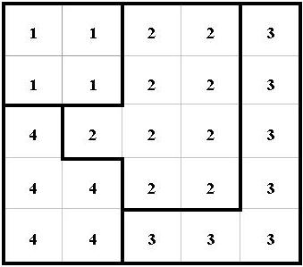



The resulting combine yields a raster dataset where groups are formed from the inputted census summary levels by continuous environmental condition as shown in Raster 3. Finally an arithmetic mean is applied within each unique census summary ‘zone’, to yield a raster surface like depicted in Raster 4.

Raster 3 Raster 4

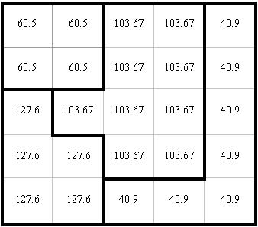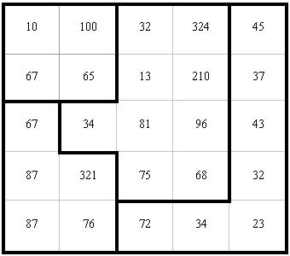

## Analysis Study Area

The project area will be San Joaquin County. See Map 1. There are 563,598 people in San Joaquin County, 73% are white, and 17% are minority, and 97,195 are listed below the poverty level (US Census Bureau 2002, California Department of Finance, 2002). San Joaquin County contains a reasonable amount of urban and rural areas. San Joaquin County is entirely contained in the California Department of Water Resources San Joaquin Valley Ground Water Basin. Moreover San Joaquin County is finished with its Drinking Source Water Assessment.

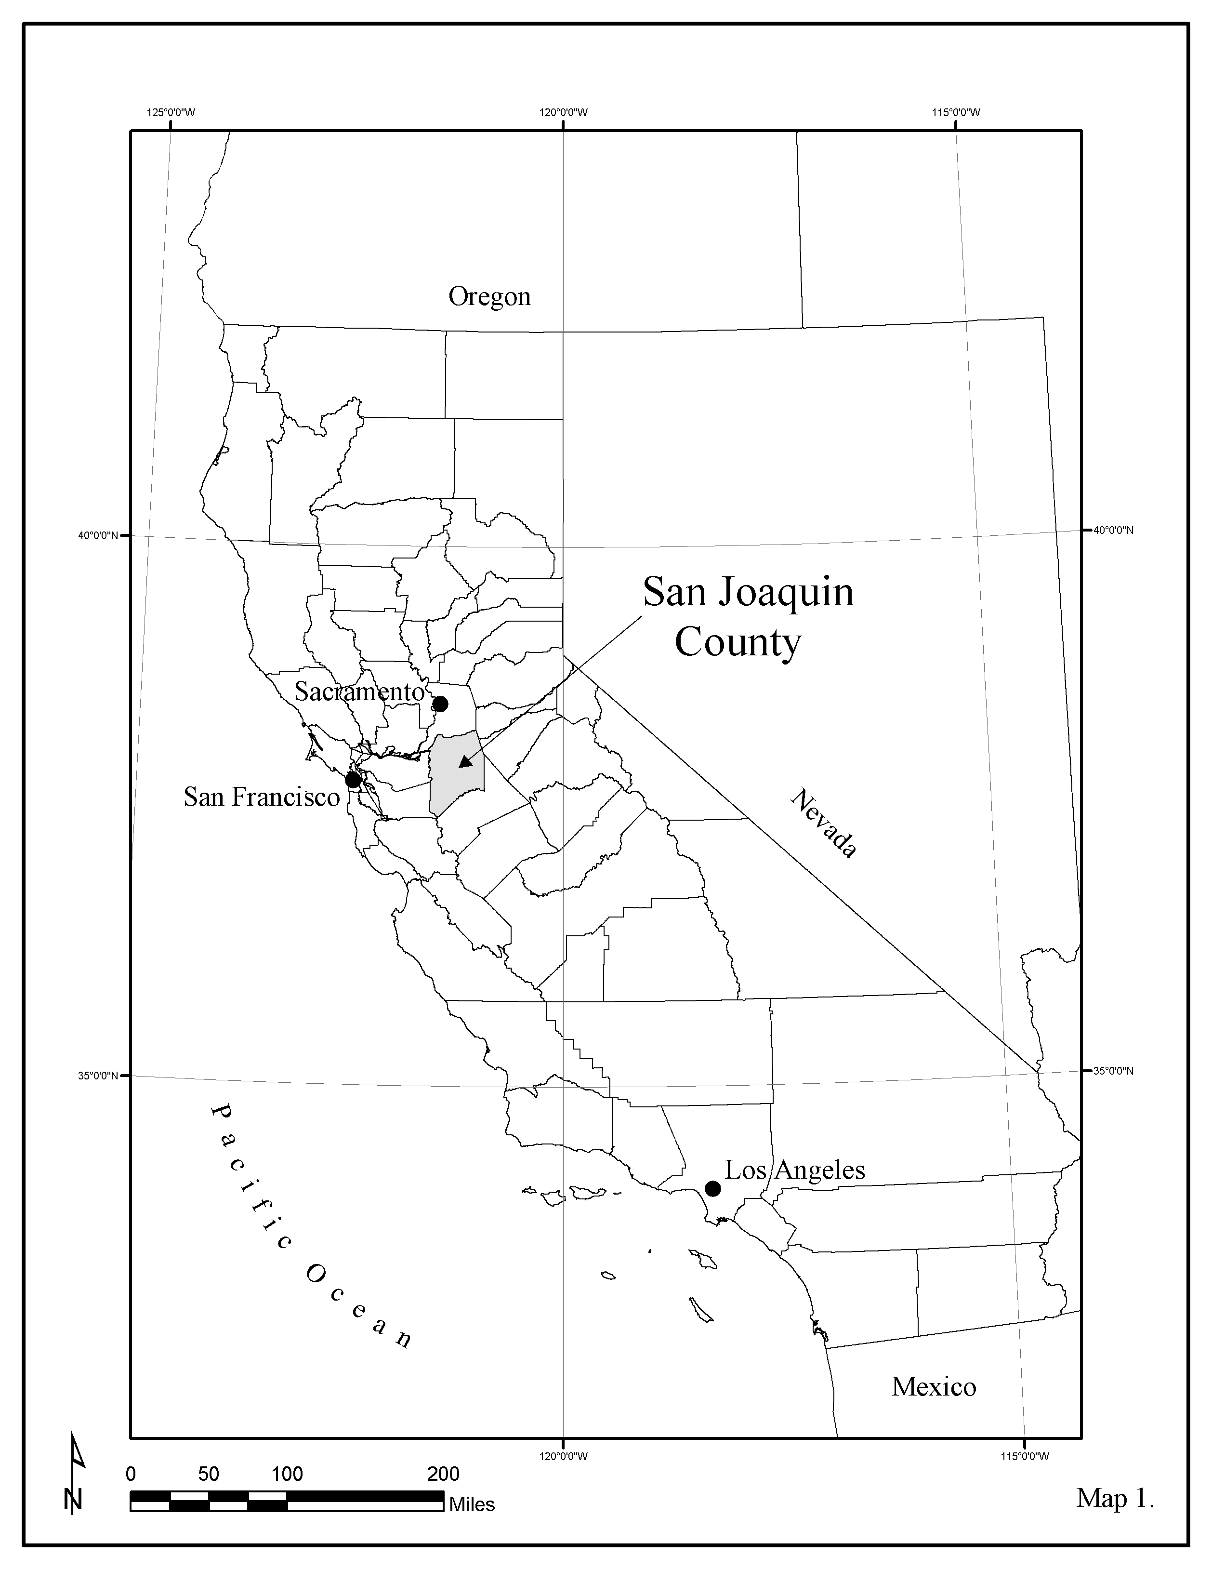

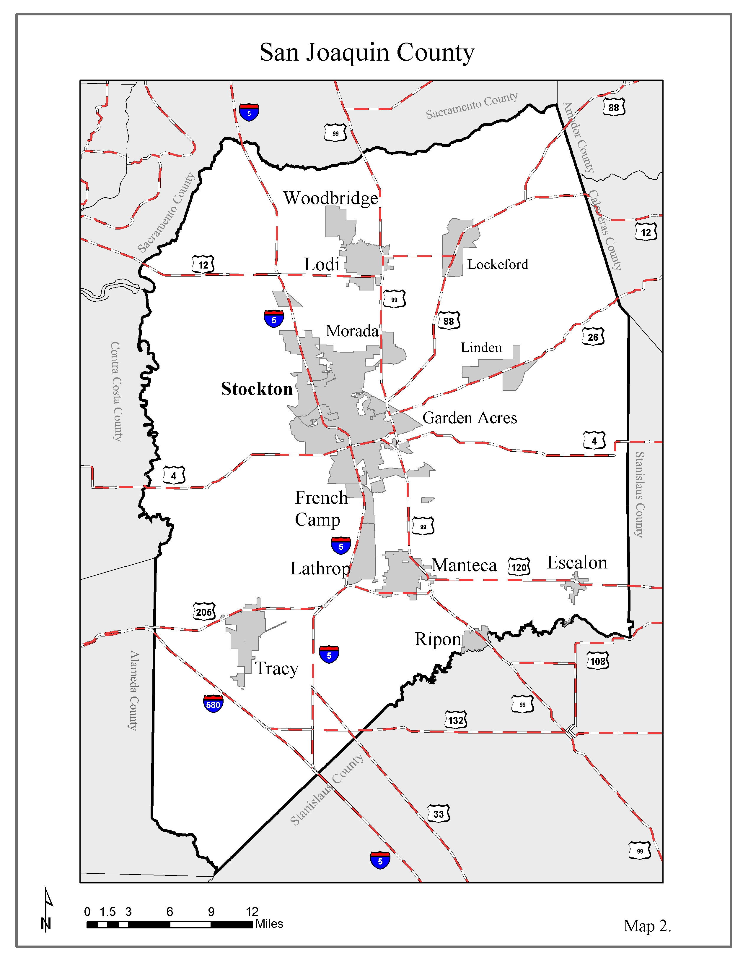

# Results

**Drinking Water Source Geography.** Map 3 shows the distribution of public drinking water sources in San Joaquin County. 967 public drinking water sources were used in the analysis in the County.

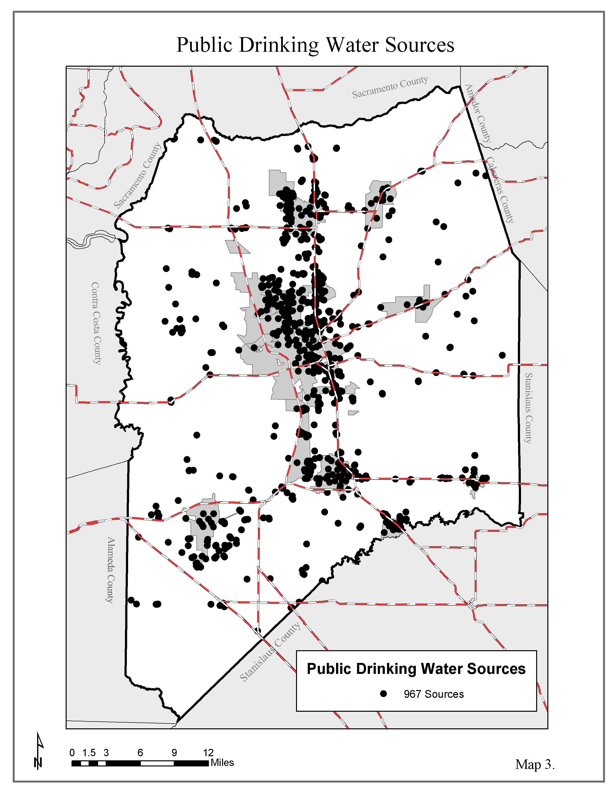

**Toxic Release Inventory Geography.** Map 4 illustrates the geography of the 107 US Environmental Protection Agency Toxic Release Inventory Sites in San Joaquin County.

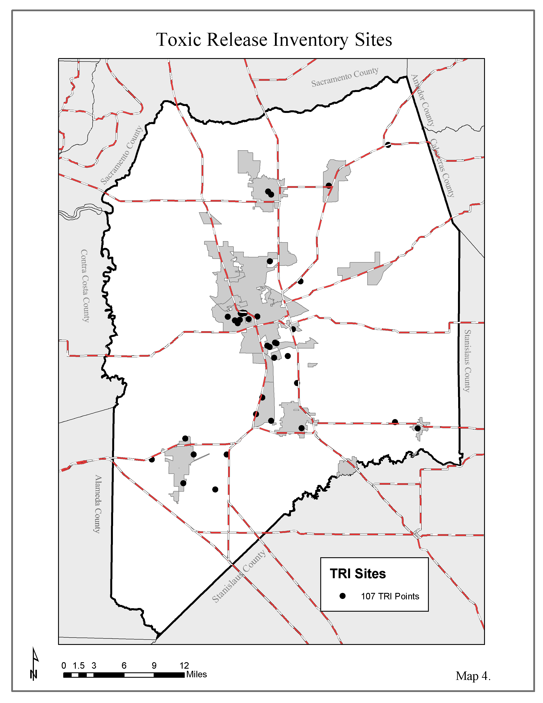**Census Geography.** Maps 5 illustrates the geographic characteristics of census blocks polygons in San Joaquin County. This GIS datasets contains attribute values for % White, and % at risk (age less than 5 and greater than 65).

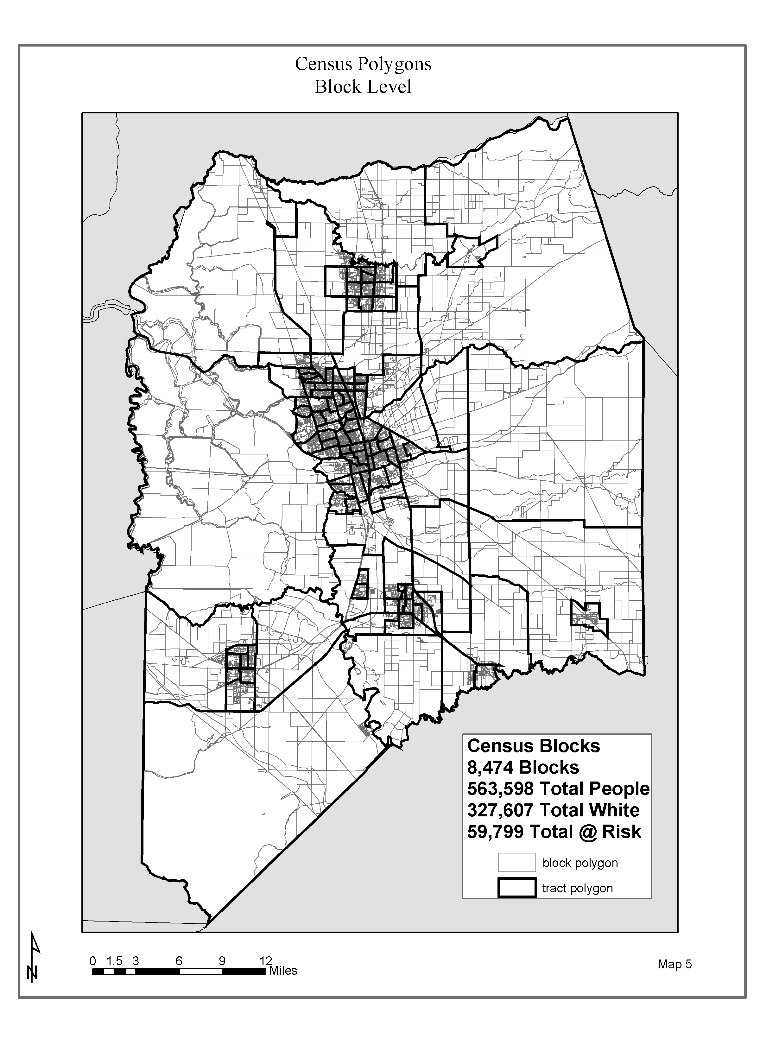**Census Geography.** Maps 6 illustrates the geographic characteristics of census block group polygons in San Joaquin County. This GIS datasets contains attribute values for % below poverty status (age less than 5 and greater than 65).

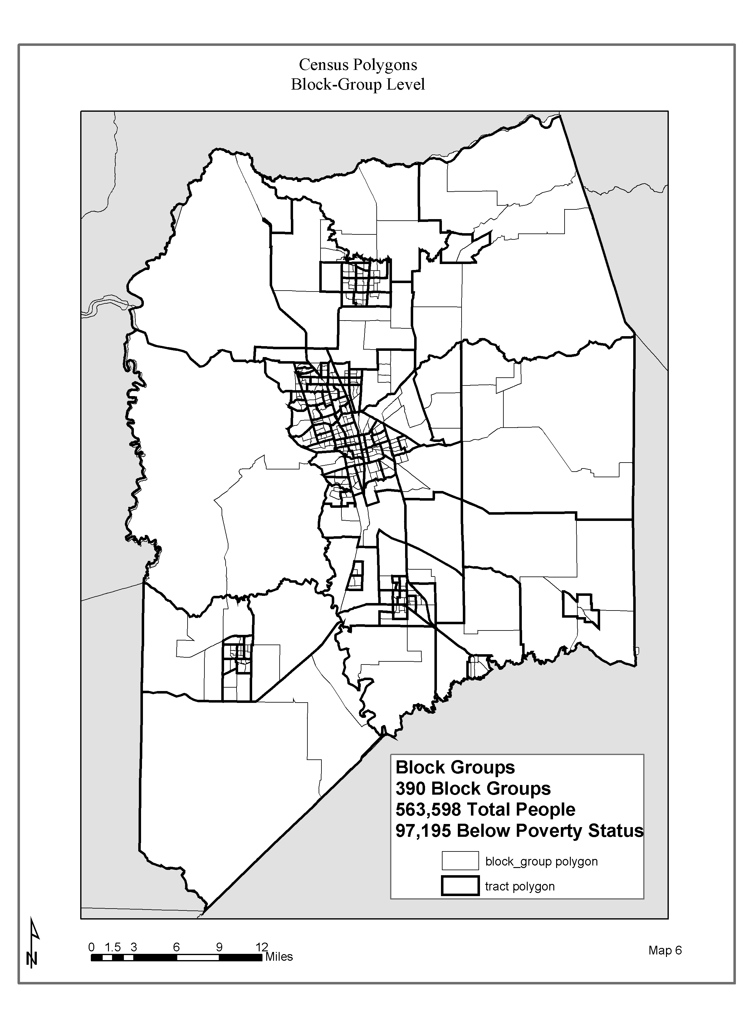

**Census Geography.** Maps 7 illustrates the geographic characteristics of census tract polygons in San Joaquin County. This GIS datasets contains attribute values for % below poverty status, % at risk (age less than 5 and greater than 65) and % white.

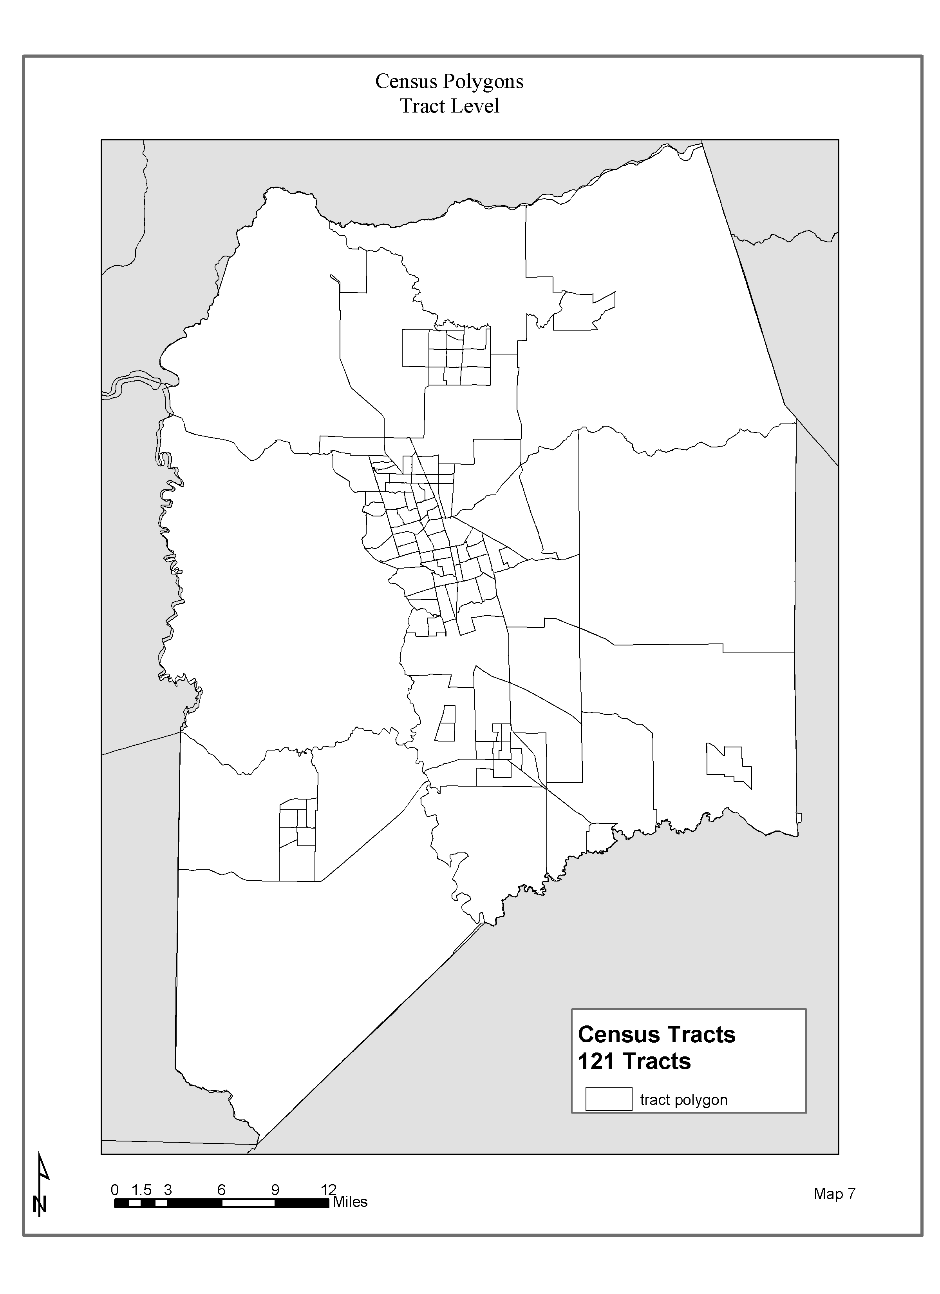

**Environmental Condition Continuous Surfaces.** Maps 8 illustrates the results of the IDW algorithms on the public drinking water system sources for the number of hits over the maximum contamination level.

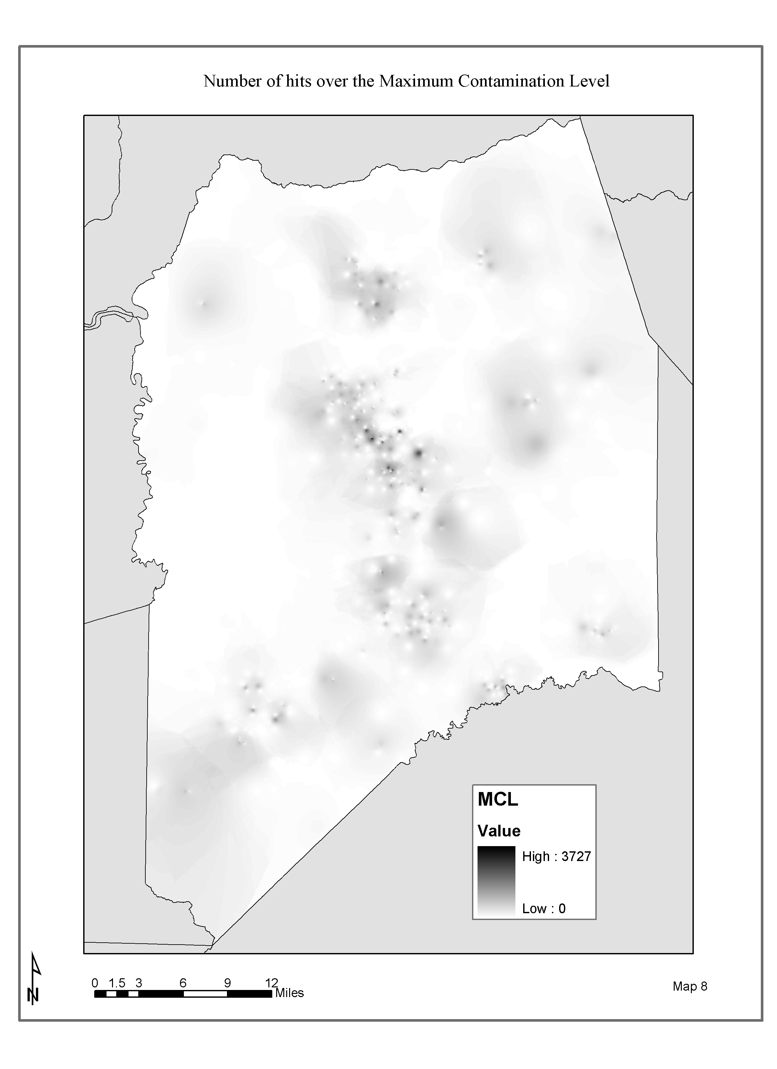**Environmental Condition Continuous Surfaces.** Maps 9 illustrates the results of the IDW algorithms on the public drinking water system sources for the number of different possibly contaminating activities.

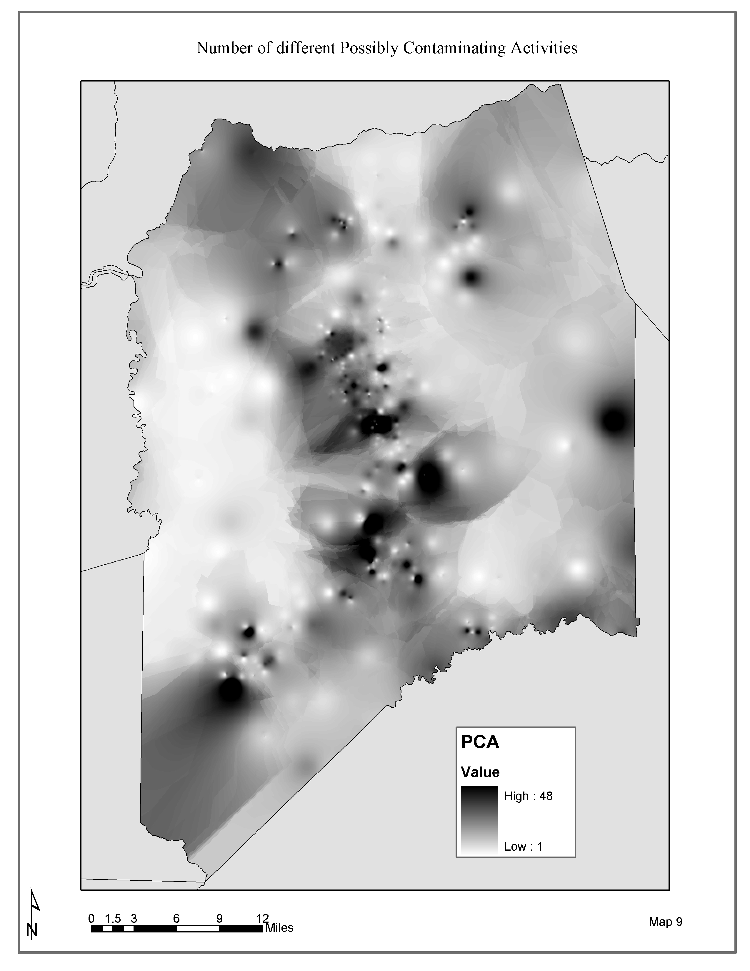**Environmental Condition Continuous Surfaces.** Maps 10 illustrates the results of the IDW algorithms on the public drinking water system sources for the number of different possibly contaminating activities.

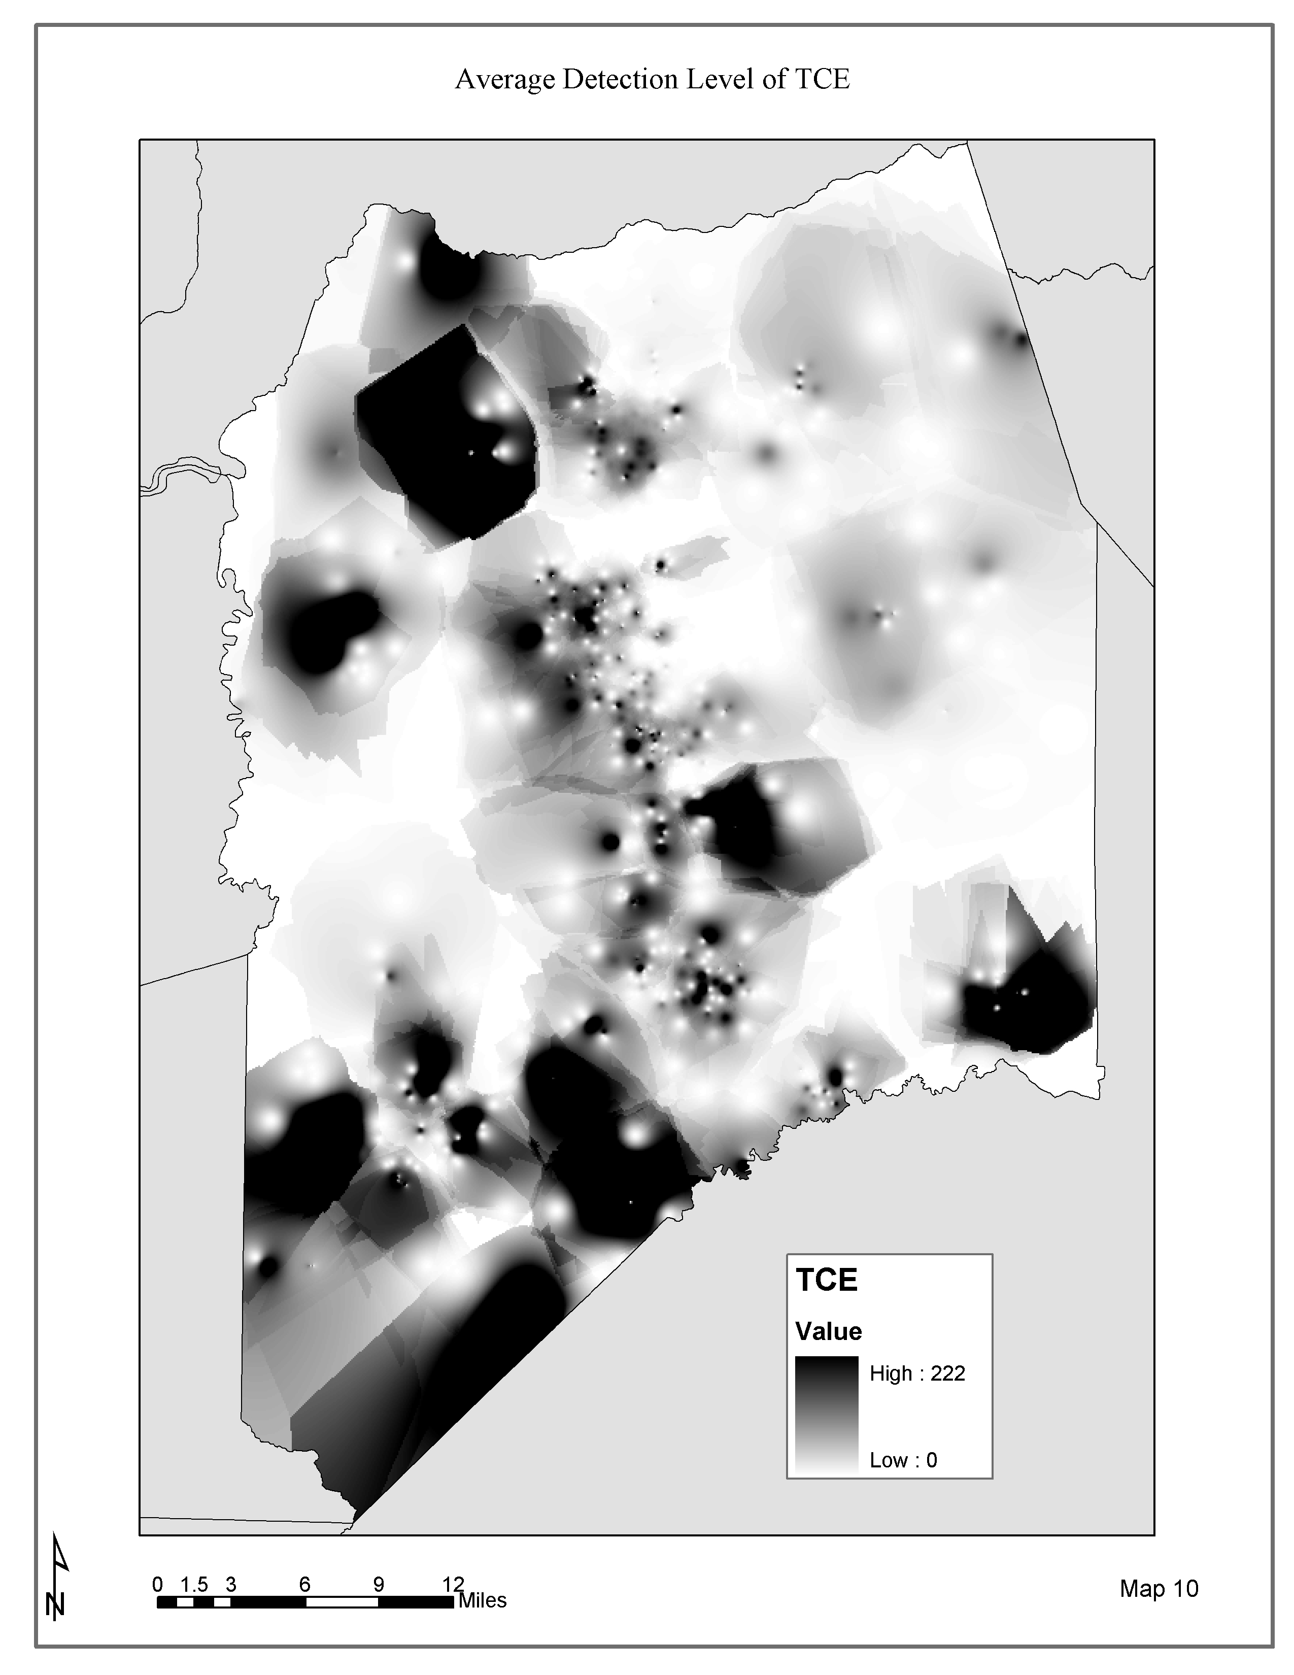

**Human Condition surfaces.** Maps 11 depicts the distribution of Percent White (Human Condition Variable) at the Census Block level.

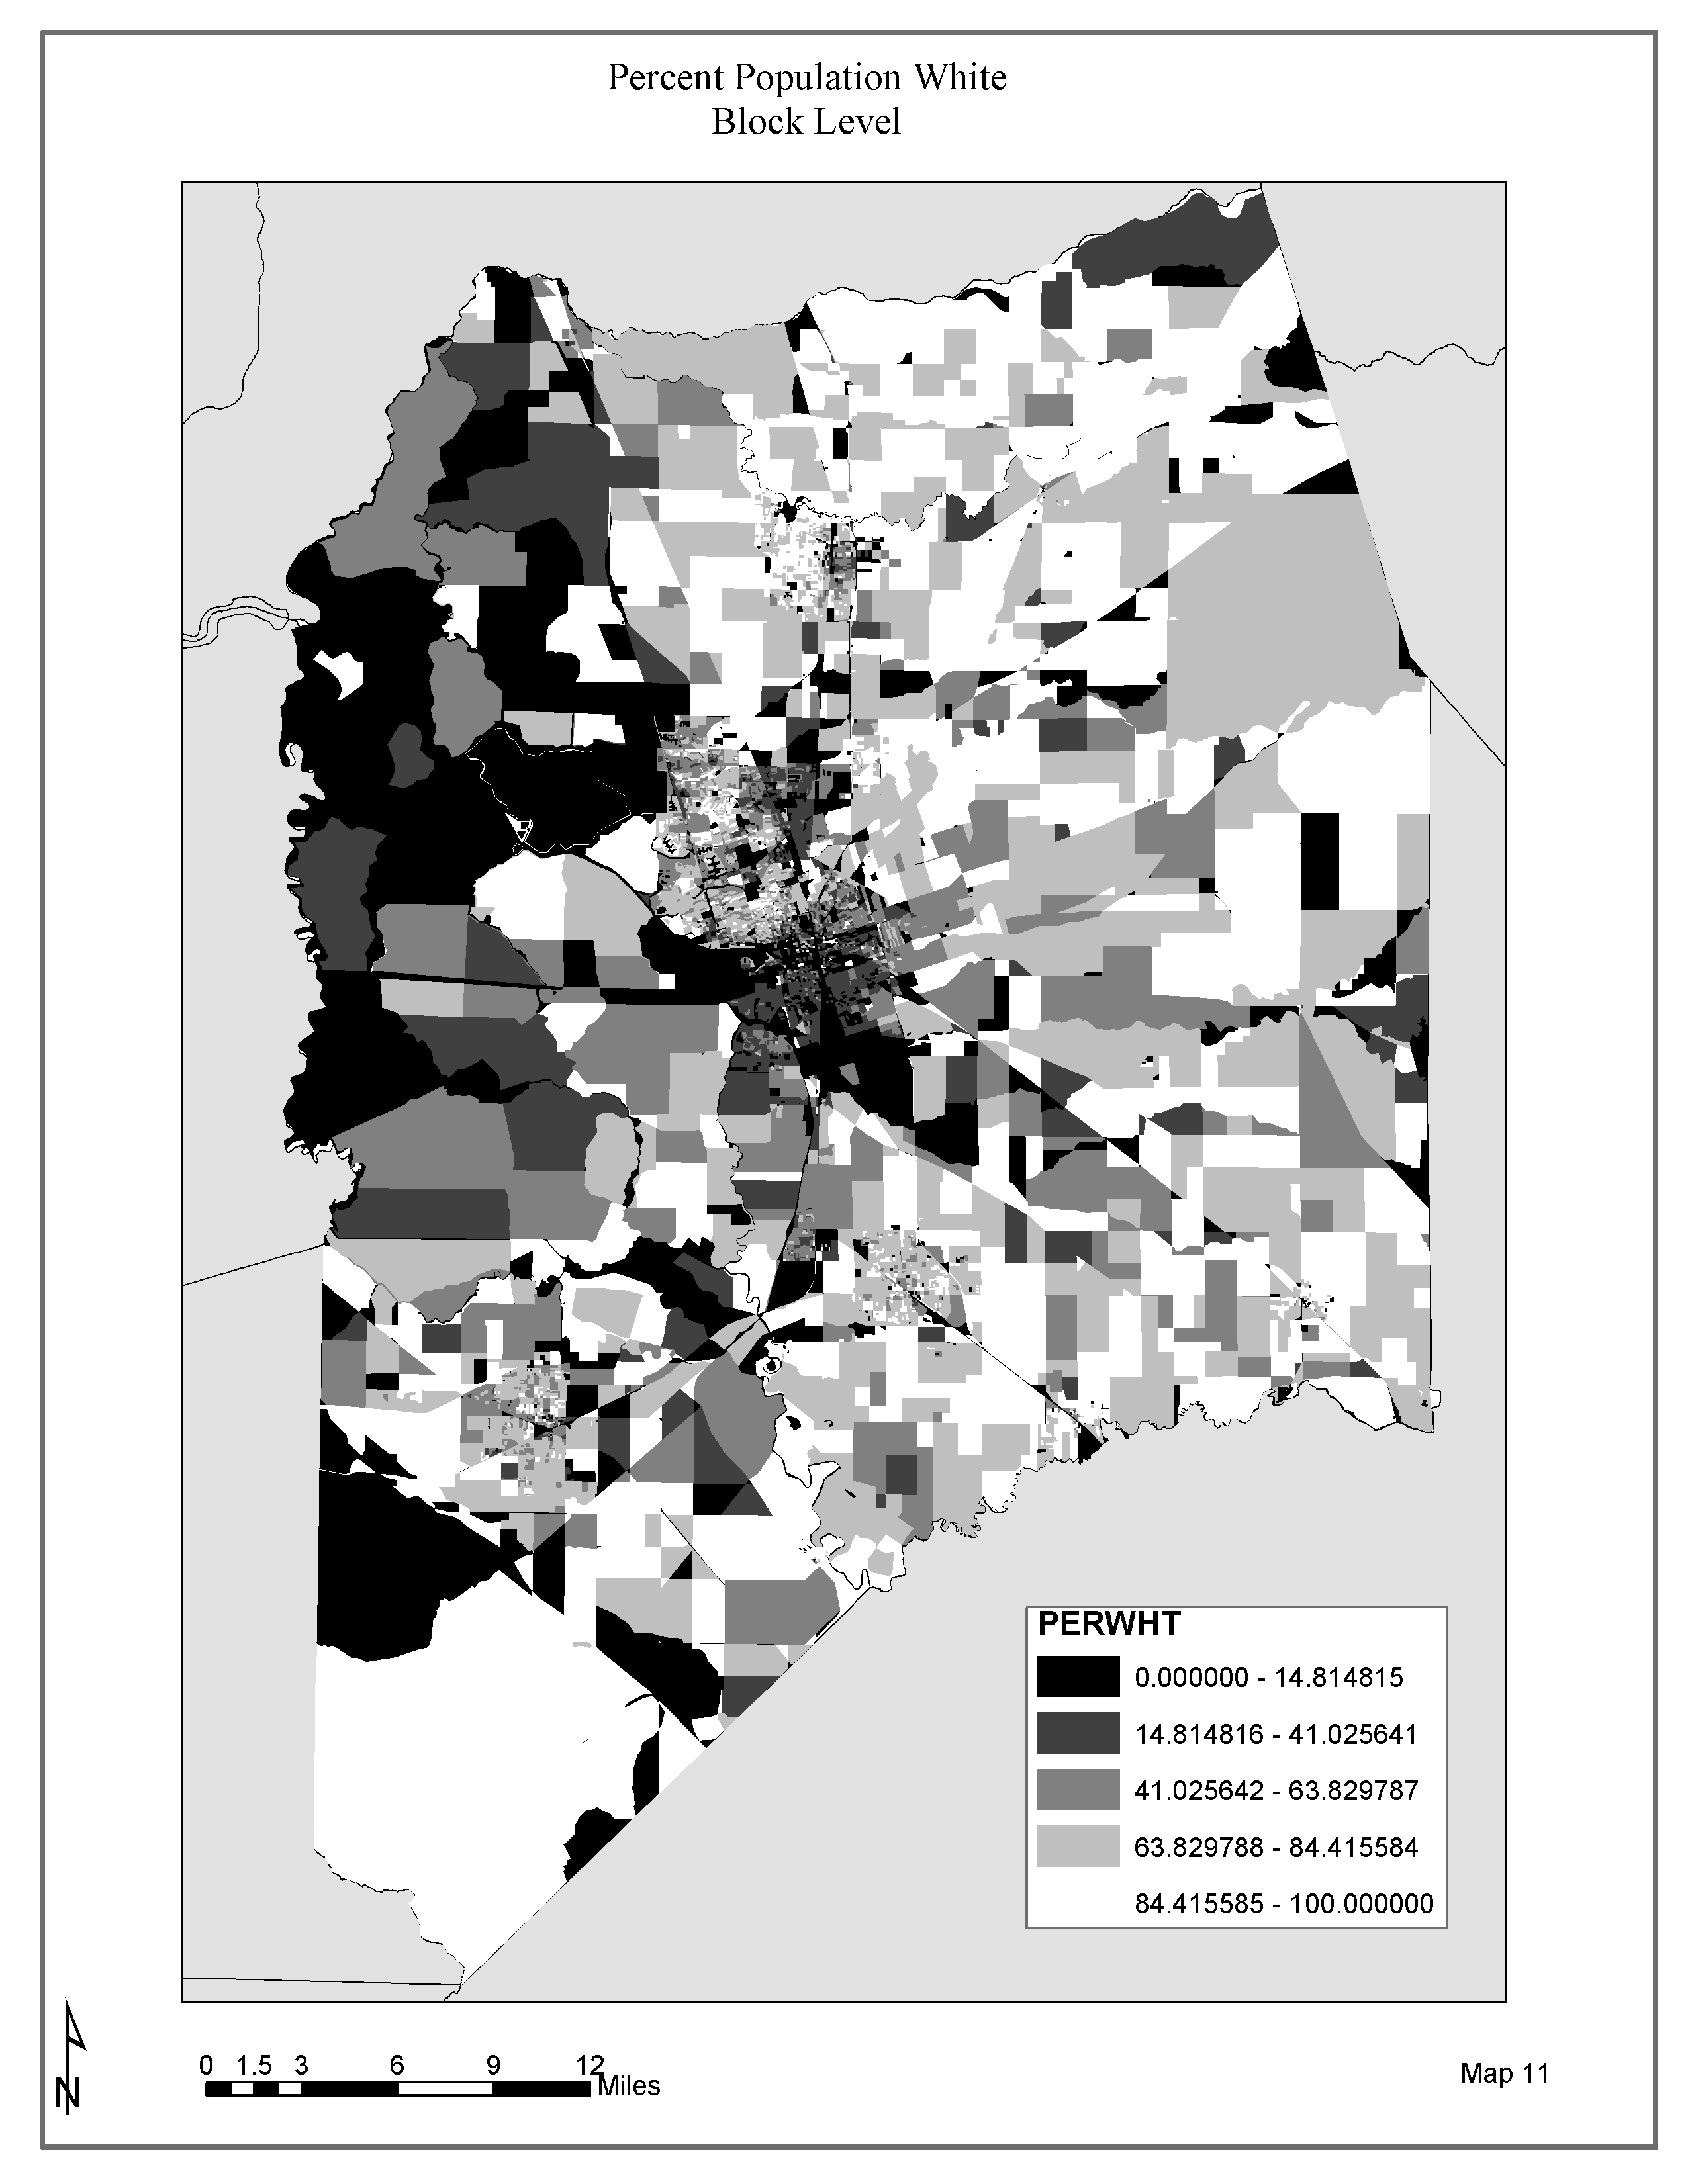**Human Condition surfaces.** Maps 12 depicts the distribution of Percent at Risk – Below age 5 or above age 65. (Human Condition Variable) at the Census Block level.

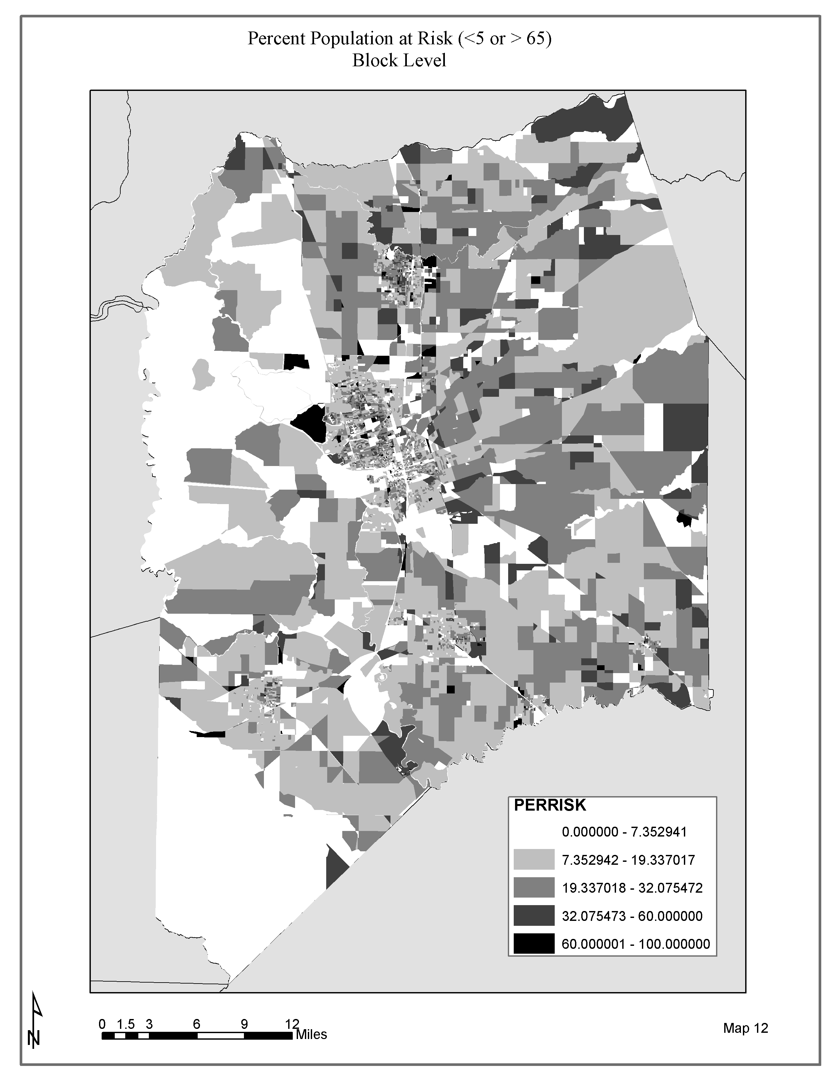**Human Condition surfaces.** Map 13 depicts the distribution of Percent Below Poverty Status at the Block Group level.

## ..\..\maps\final\map13.jpgRegression Results

# *Simple Linear Regression Results for % Below Poverty Status*

|  |  |  |
| --- | --- | --- |
| MCL | PCA | TCE |
|  |  |  |

R2 Values

|  |  |  |
| --- | --- | --- |
| MCL | PCA | TCE |
| 0.040372* | 0.127598* | 0.000918 *** |

* Significant at the P < 0.0001 level

*** Not significant

*Simple Linear Regression Results for Percent at Risk (age < 5 or > 65)*

|  |  |  |
| --- | --- | --- |
| MCL | PCA | TCE |
|  |  |  |

Due to large number of sampling points in very low (0 – 5 percent) and very high (95 – 100 percent) ranges, regression was performed on the X value rank. All Dependent variables where transformed with to SQRT (Y) to correct for normality of residuals.

R2 Values (Adjusted R2 reported)

|  |  |  |
| --- | --- | --- |
| MCL | PCA | TCE |
| 0.012385* | 0.000117*** | 0.000231*** |

* Significant at the P < 0.0001 level

** Significant at the P < 0.01 level

*** Not significant

*Simple Linear Regression Results for Percent White*

|  |  |  |
| --- | --- | --- |
| MCL | PCA | TCE |
|  |  |  |

Due to large number of sampling points in very low (0 – 5 percent) and very high (95 – 100 percent) ranges, regression was performed on the X value rank. All Dependent variables where transformed with to SQRT (Y) to correct for normality of residuals.

R2 Values (Adjusted R2 reported)

|  |  |  |
| --- | --- | --- |
| MCL | PCA | TCE |
| 0.000038*** | 0.042994* | 0.001295** |

* Significant at the P < 0.0001 level

** Significant at the P < 0.001 level

*** Not significant

Analysis of the residuals for the Percent at Risk and Percent White yielded a non-normal distribution. Both log and square root Transformations to the dependent variables were applied. Whiles these transformations yielded normally distributed residuals with the same significance but inflated r2 values. I therefore kept the non-transformed statistics.

Logistic Regression Results for Toxic Release Inventory by Tract Analysis

|  |  |  |
| --- | --- | --- |
| **BPS** | **% @ Risk** | **% White** |
|  |  |  |

R2 Values

|  |  |  |
| --- | --- | --- |
| BPS | % @ Risk | % White |
| 0.0038*** | 0.0038*** | 0.0125*** |

* Significant at the P < 0.0001 level

*** Not significant

# Discussion

This research was designed to test two questions. First is there an environmental equity difference in environmental condition across demographics – i.e., are neighborhoods with more minorities, immigrants, poor people, or very young and very old people more likely to be supplied with polluted drinking water? Second does the use of continuous surfaces at a larger scale provide better results than traditional statistical methods for assessing environmental equity? I will discuss these issues and present a point of departure for additional research.

The environmental and demographic variables used, e.g., percent white, percent below the poverty status and percent at risk are all commonly used in environmental equity research (Mantaay 2002). Moreover, I decided to use two risk variables and an exposure variable for environmental condition. These variables are new, as the current literature includes very few papers using drinking water quality for environmental equity researched (but see Pontius 2000). Use of these variables demonstrates a solid matrix for analyzing the two fundamental questions to this research.

The resulting statistical analysis illustrates a weak positive relationship between percent below poverty level for both risk variables with a high degree of significance, given the very large sample sizes. This result demonstrates that as the percent poverty increases, risk also increases, but poverty is nevertheless a very weak predictor of risk. The percent at risk analysis yields a weak positive relationship for all variables (highly significant for one risk variable and relatively high for the other risk variable and the exposure variable). This result demonstrates that as risk and exposure increase, the percent at risk increases as well. The percent white analysis yields a weak inverse relationship for one risk variable (again, with a high degree of significance). This analysis demonstrates that as risk raises the percent white declines. However, the results also show no significant relationship for the other risk variable and the exposure variable. While a definitive result regarding an unequal burden is not without doubt due to low *r2* values, a high degree of significance suggests that there is an unequal burden across some demographic variables.

These low values are the likely result of significant noise in the distribution of the demographic landscape. Barring the results of the percent below poverty status, San Joaquin County is a highly fragmented county demographically. Maps 11, 12, and 13 illustrate few contiguous spaces of similar human condition. I would expect higher *r2* values and thus a stronger coefficient of unequal burden in areas where there are more homogeneous contiguous demographic landscapes.

Bowen (2002) argues strongly there is little “high quality scientific research”, which adequately proves there is an unequal burden borne by people of color or low economic status. My research demonstrates through rigorous scientific methods, there is a significant but weak relationship. The spatial methods I employ combined with the strength of the linear relationship do suggest there is an unequal burden borne across demographic variables. While this conclusion is specific to San Joaquin County California, the results are significant enough to merit investigation on a larger study area and in another part of the country. The spatial methods employed in my research are robust enough to support the unequal burden claim. However more analysis is needed to determine whether increased toxic exposures are important compared with other known health risks to poor and minority communities, including less access to health care or education level.

Foremen (1998) argues we, as researchers, need to demonstrate a significant relationship including exposure, which results in adverse health conditions (e.g. not just risk). While these conclusions are shown in some research, most still use only ‘risk’ bases measures. My research shows a method for which actual exposure through the public drinking water system could demonstrate physical ingestion of the unequal burden. My results indicate there is no significant relationship for exposure and either percent below poverty or percent white. However a weak relationship for percent at risk does exist. This weak relationship merits further investigation into real health conditions. The value in using continuous average levels of exposure to substances like TCE is clearly demonstrated. It is plausible that the spatial distribution of some rarer toxicants, such as agricultural chemicals, is more inequitably distributed, but larger study regions may be needed to develop the sample sizes needed to test for such effects.

In the second question of the research, my research shows opposite results. Using the TRI sites and block level demographic data the analysis shows absolutely no unequal burden in environmental condition. However, as stated above, using the continuous data at the block (and block group) levels the analysis does support an unequal burden claim. These results demonstrate the current frustration researchers in environmental justice have faced. Which results do we believe? The continuous method is a more rigorous scientific method. Using this method on a very heterogeneous data set, like the block level data, will continue to provide us with results, which more adequately represent real world conditions (See Openshaw 1983).

The methods employed allow us several advantages. First it allows us to use the most refined demographic polygon data. Using this scale, we have very many data points (my analysis n = 8261). The use of many data points probably points to my very low Pvalues, which is a definite advantage. However, this scale may also point to the very low r2 values and bring out more the fragmented landscape. Second it allows us to explore real exposure data. My use of a TCE concentrate shows a real example of average TCE level in the public drinking water system over the last 20 years. Using this method might help us articulate the exposure and health effects Foreman argues for. Finally this method provides excellent flexibility in experimental design. I employed a good cross section of environmental and human condition variables, but many other variables could have been chosen and do indeed merit further investigation.

In conclusion, while many researchers have argued significance in both an equal and unequal burden in environmental condition, no one has been able to demonstrate either with continuous surfaces of threat and exposure using the public drinking water system. My research shows promises both as an analytical method and as a result of showing there is an unequal burden across demographics in a region of California in which welfare of the rural poor and immigrant communities are recognized policy challenges. The analytic framework should permit us, as drinking water assessments become available over the next few years, to scale the analysis over much larger areas, threat types, and kinds of demographic diversity.

Literature Cited

1. Bowen, W. "An Analytical Review of Environmental Justice Research: What Do We Really Know?" Environmental Management V29.N1 (2002): 3-15.

2. BOWEN WM, et al. "Toward Environmental Justice - Spatial Equity in Ohio and Cleveland." Annals of the Association of American Geographers V85.N4 (1995): 641-63.

3. Burke, L. "Race and Environmental Equity: A Geographic Analysis in Los Angeles." Geo Info Systems 3.9 (1993): 44-50.

4. California Department of Health Services. "Drinking Water Source Assessment Database." Database. Sacramento: California Department of Health Services, 2002.

5. ---. "Water Quality Monitoring Database." 1980 - 2001. Compact Disk. Sacramento, Ca.: Drinking Water Program, 2001.

6. CUTTER SL, and SOLECKI WD. "Setting Environmental Justice in Space and Place - Acute and Chronic Airborne Toxic Releases in the Southeastern United States." Urban Geography V17.N5 (1996): 380-99.

7. Foreman, Christopher H. "The Promise and Peril of Environmental Justice /.". Washington, D.C. : Brookings Institution, 1998.

8. Glickman, Theodore S. "Measuring Environmental Equity With Geographical Information Systems." Renewable Resources Journal (1994).

9. Harner, J, et al. "Urban Environmental Justice Indices." Professional Geographer V54.N3 (2002): 318-31.

10. Maantay, J. "Mapping Environmental Injustices: Pitfalls and Potential of Geographic Information Systems in Assessing Environmental Health and Equity." Environmental Health Perspectives V110.SUPP2 (2002): 161-71.

11. McMaster, Robert B., Helga Leitner, and Eric Sheppard. "GIS-Based Environmental Equity and Risk Assessment:Methodological Problems and Prospects." Cartography and Geographic Information Systems 24.3 (1997): 172-89.

12. Newton, David E. "Environmental Justice : a Reference Handbook /."Contemporary World Issues. Santa Barbara, Calif. : ABC-CLIO, 1996.  
Notes: Includes bibliographical references and index  
English

13. Openshaw, Stan. "The Modifiable Areal Unit Problem /."Concepts and Techniques in Modern Geography No. 38 0306-6142 . Norwick [Norfolk] : Geo Books, 1983.

14. PERLIN SA, et al. "Distribution of Industrial Air Emissions by Income and Race in the United States - an Approach Using the Toxic Release Inventory." Environmental Science & Technology V29.N1 (1995): 69-80.

15. Philip, G M, D F Watson, and P N chairperson Jamieson. "A Precise Method for Determining Contoured Surfaces." The APEA Journal, Vol.22, Part 1, Pp.205-212, 1982 (1982).

16. Pontius, FW. "Environmental Justice and Drinking Water Regulations." Journal American Water Works Association V92.N3 (2000): 14,16,18,20,104.

17. Sheppard, E, et al. "Gis-Based Measures of Environmental Equity: Exploring Their Sensitivity and Significance." Journal of Exposure Analysis and Environmental Epidemiology V9.N1 (1999): 18-28.

18. U.S. Census Bureau. "Census 2000." Summary File 3. Data File. Washington, D.C.: U.S. Census Bureau, 2002.

19. ---. "Census 2000." Summary File 1. Data File. Washington, D.C.: U.S. Census Bureau, 2002.

20. U.S. Environmental Protection Agency. "Toxic Release Inventory Sites." Internet Data . Washington, D.C.: U.S. Environmental Protection Agency, 2002.

21. "Toxic Wastes and Race in the United States : a National Report on the Racial and Socio-Economic Characteristics of Communities With Hazardous Waste Sites /." United Church of Christ. Commission for Racial Justice. New York, N.Y. : Public Data Access : Inquiries to the Commission, 1987.

22. "Environmental Justice Strategy : Executive Order 12898." United States and United States. [Washington, D.C.] : U.S. Environmental Protection Agency, Administration and Resources Management, Office of Environmental Justice, 1995.

23. Watson, D F, and G M Philip. "A Refinement of Inverse Distance Weighted Interpolation." Geo-Processing, Vol.4, No.2, Pp.315-327, Oct 1985 (1985).